Irregular Closed Curves
# Source: AI Source: Provided by: [Data Path: Persons Table -> ID Column: 1, Name_En Column: Motasem Essam] -> From: [ChatGPT] on [7/25/2026]
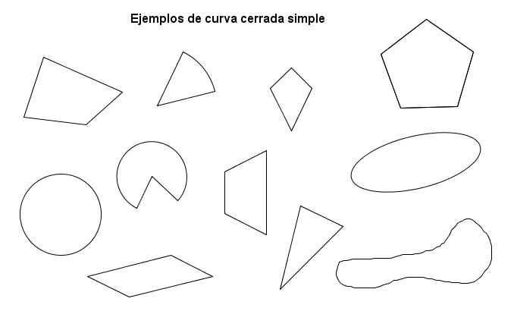
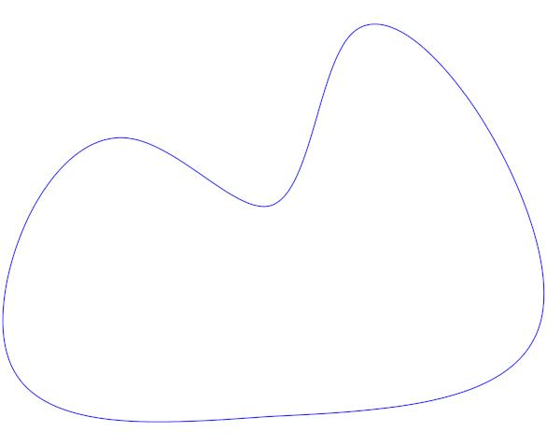
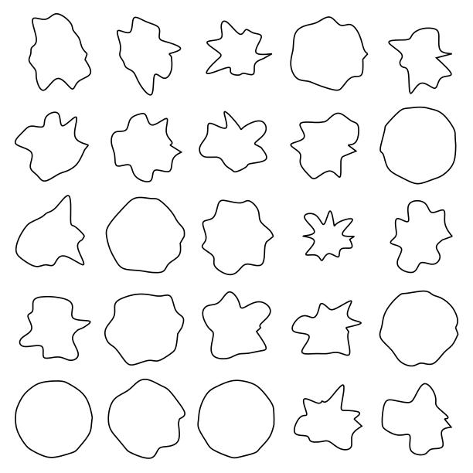
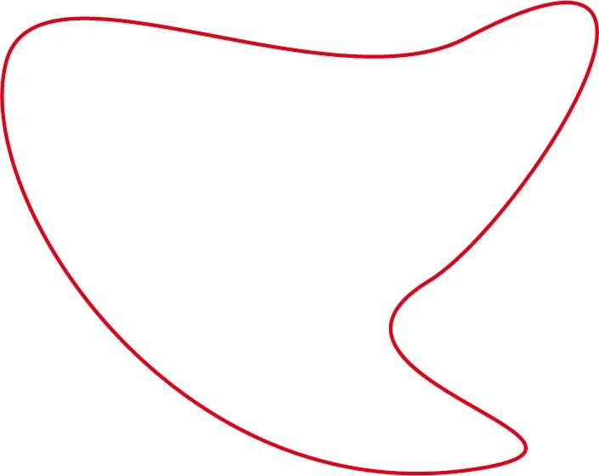
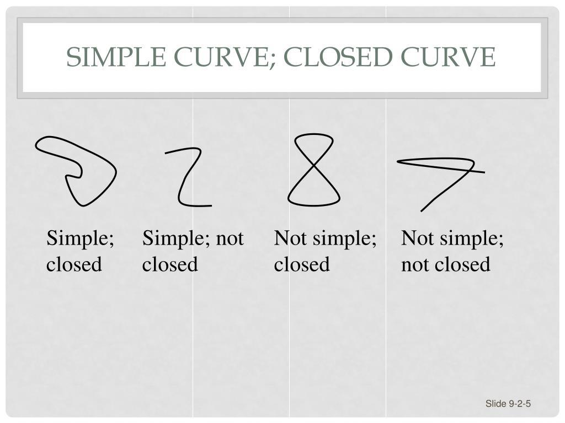

Definition
# Source: AI Source: Provided by: [Data Path: Persons Table -> ID Column: 1, Name_En Column: Motasem Essam] -> From: [ChatGPT] on [7/25/2026]
An Irregular Closed Curve is a continuous curved line whose starting point and ending point coincide, forming a closed boundary, while the curve does not follow a regular geometric form such as a circle or ellipse.
In simple terms:
An irregular closed curve is a closed, non-standard curved boundary that encloses a region.
$$\boxed{\text{Irregular Closed CurveClosed Curve}+\text{Irregular Form}}$$

Characteristics
# Source: AI Source: Provided by: [Data Path: Persons Table -> ID Column: 1, Name_En Column: Motasem Essam] -> From: [ChatGPT] on [7/25/2026]
An irregular closed curve typically:
- Is continuous.
- Has a curved boundary.
- Has coincident starting and ending points.
- Encloses a bounded region.
- Has variable curvature.
- Does not have a constant radius.
- Does not necessarily have symmetry.
- Does not have straight-line sides in its pure form.
- Usually cannot be represented by one simple standard geometric equation.

Examples

1. Irregular Organic Closed Curve
# Source: AI Source: Provided by: [Data Path: Persons Table -> ID Column: 1, Name_En Column: Motasem Essam] -> From: [ChatGPT] on [7/25/2026]
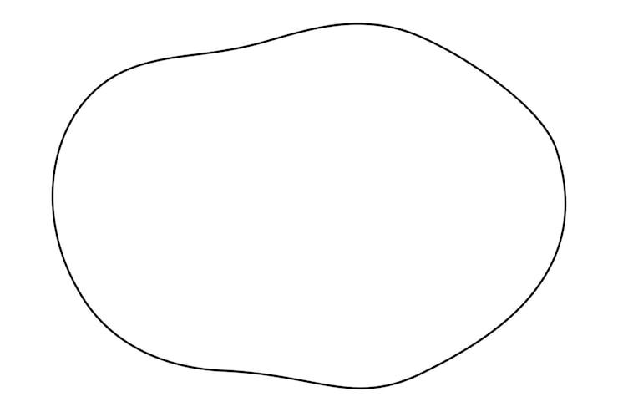
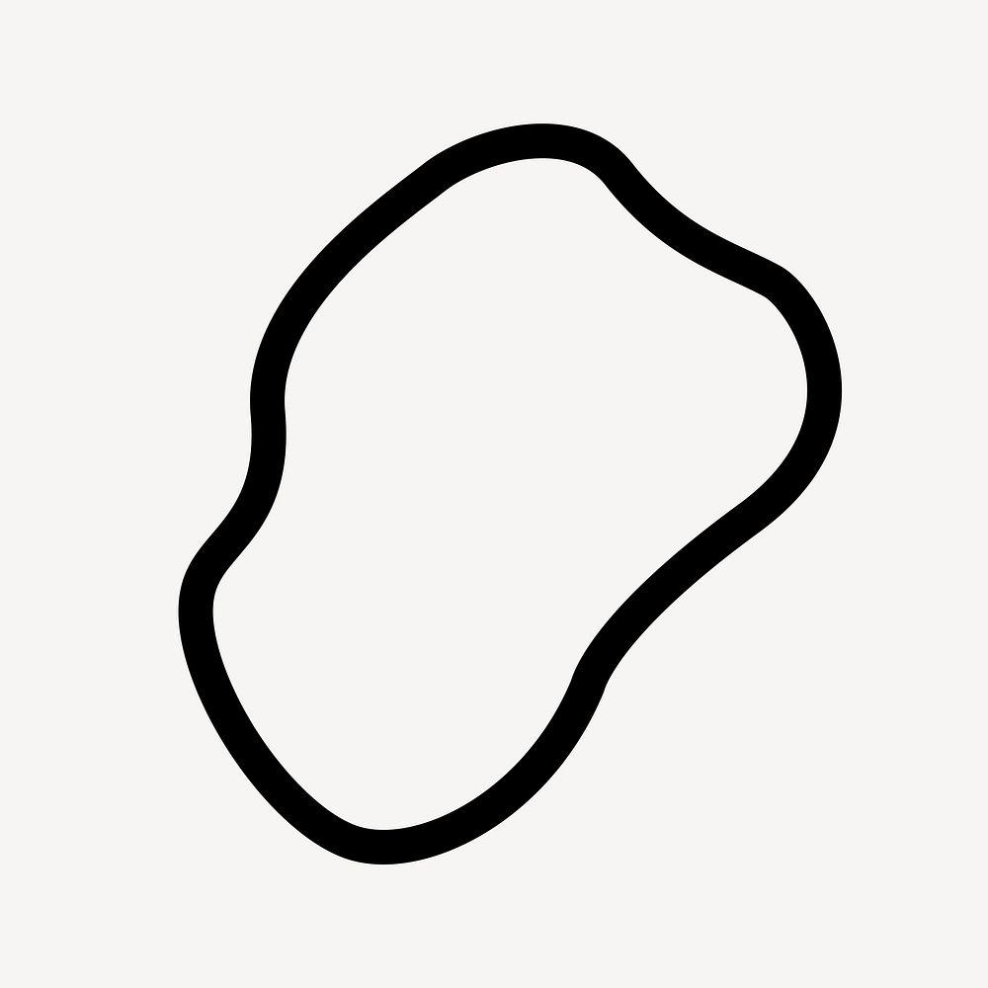
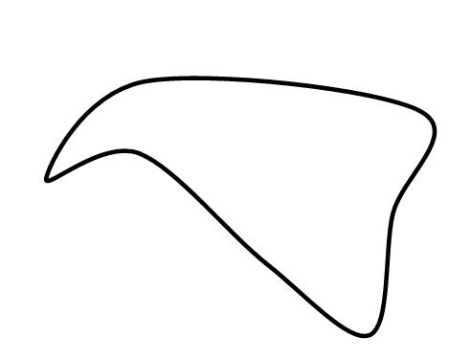
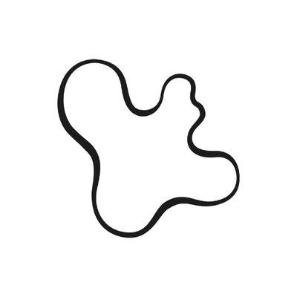
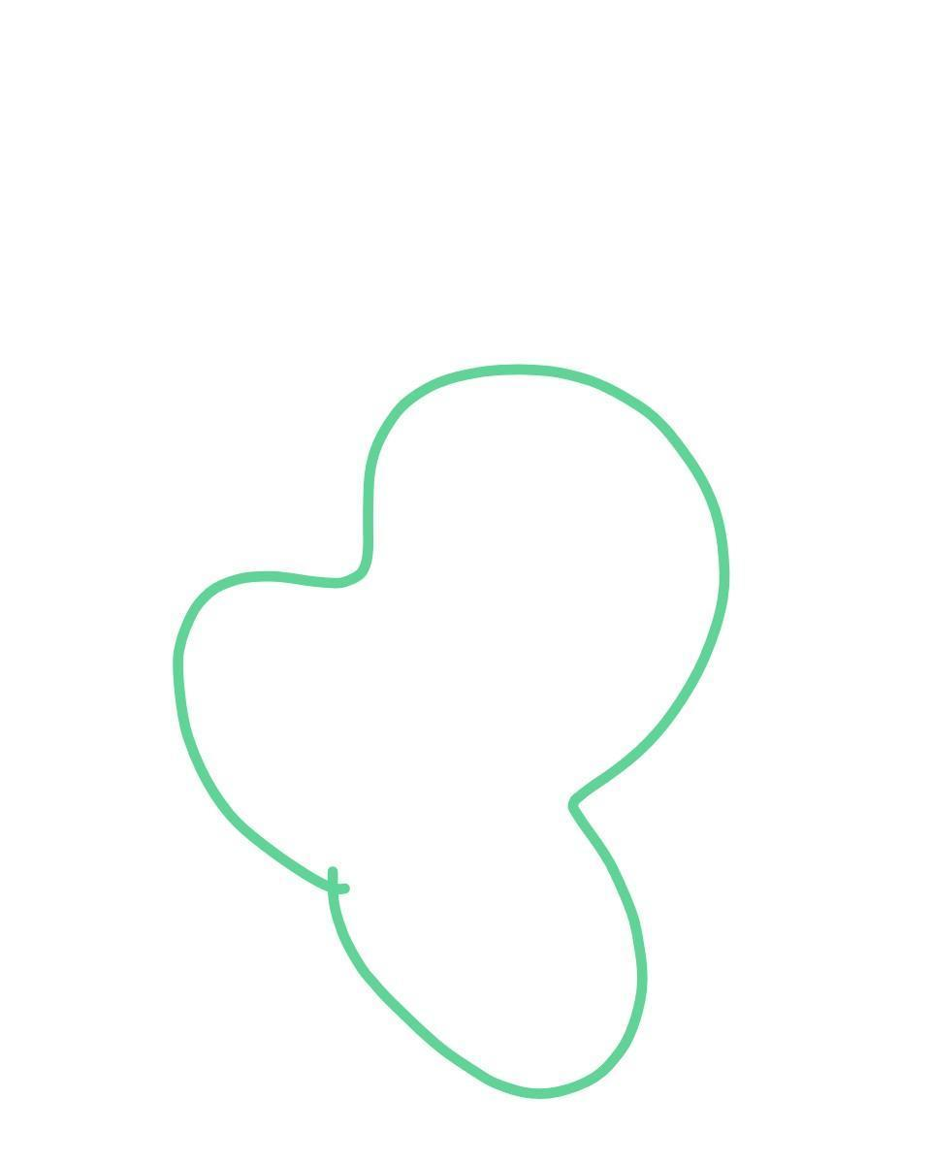
A smooth, irregular closed boundary resembling an organic form.

2. Irregular Wavy Closed Curve
# Source: AI Source: Provided by: [Data Path: Persons Table -> ID Column: 1, Name_En Column: Motasem Essam] -> From: [ChatGPT] on [7/25/2026]
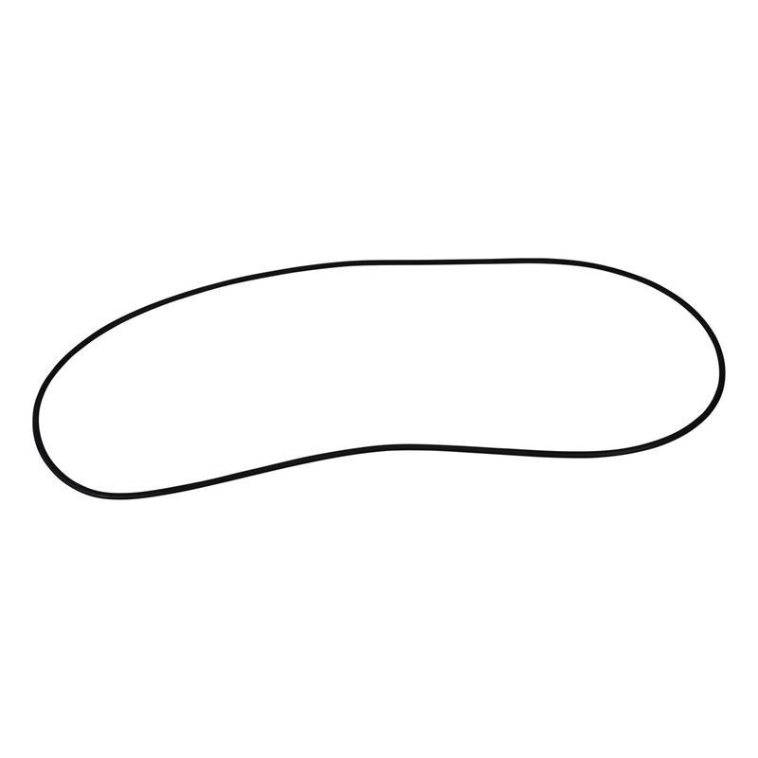
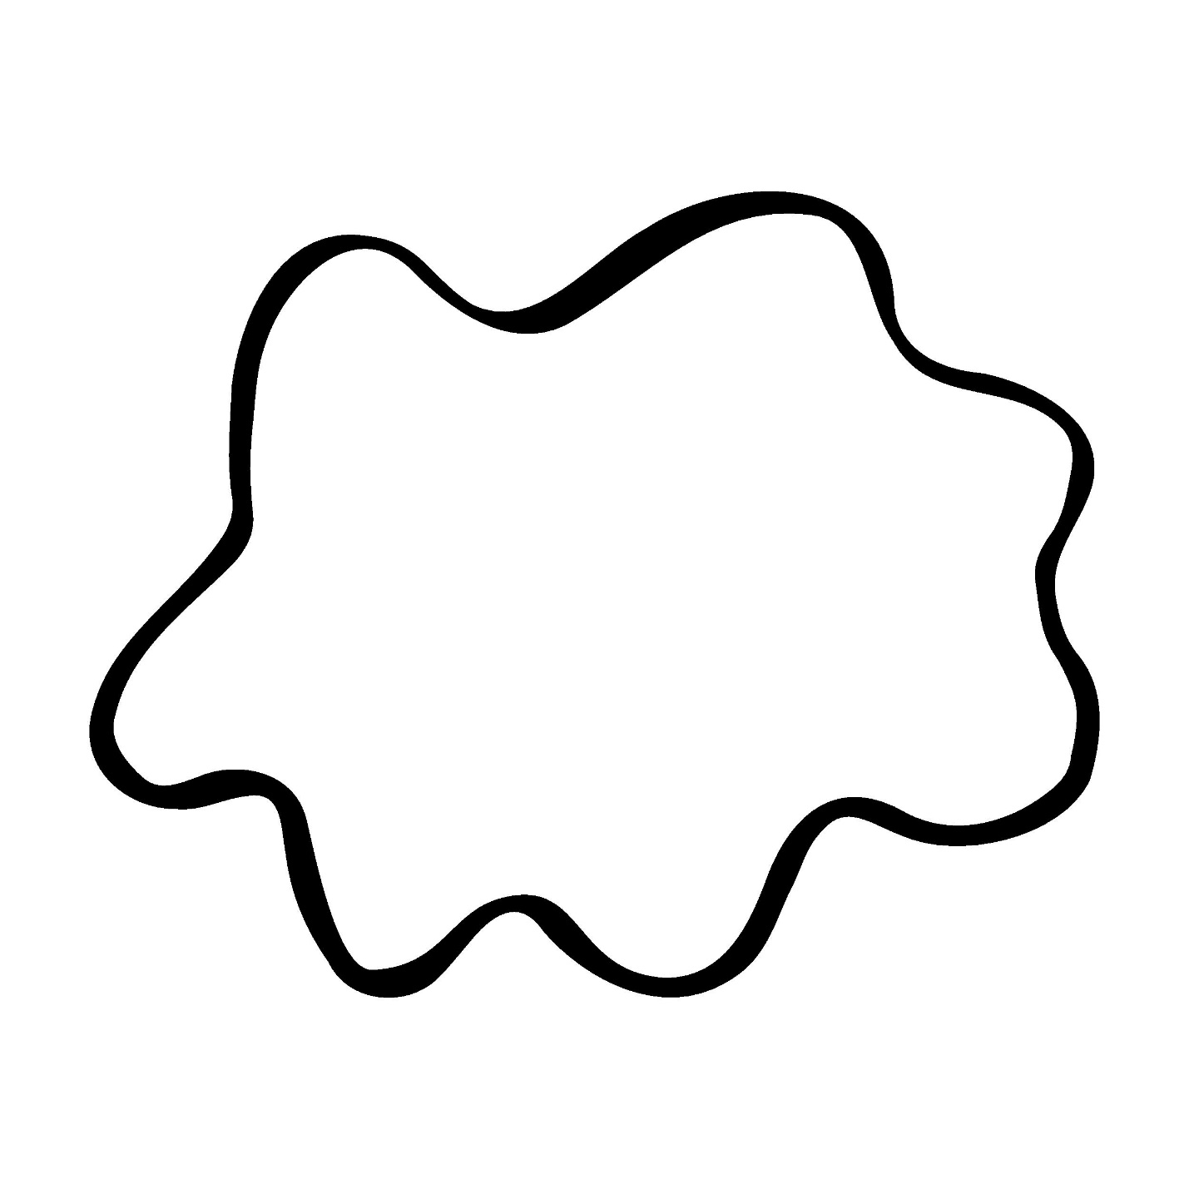
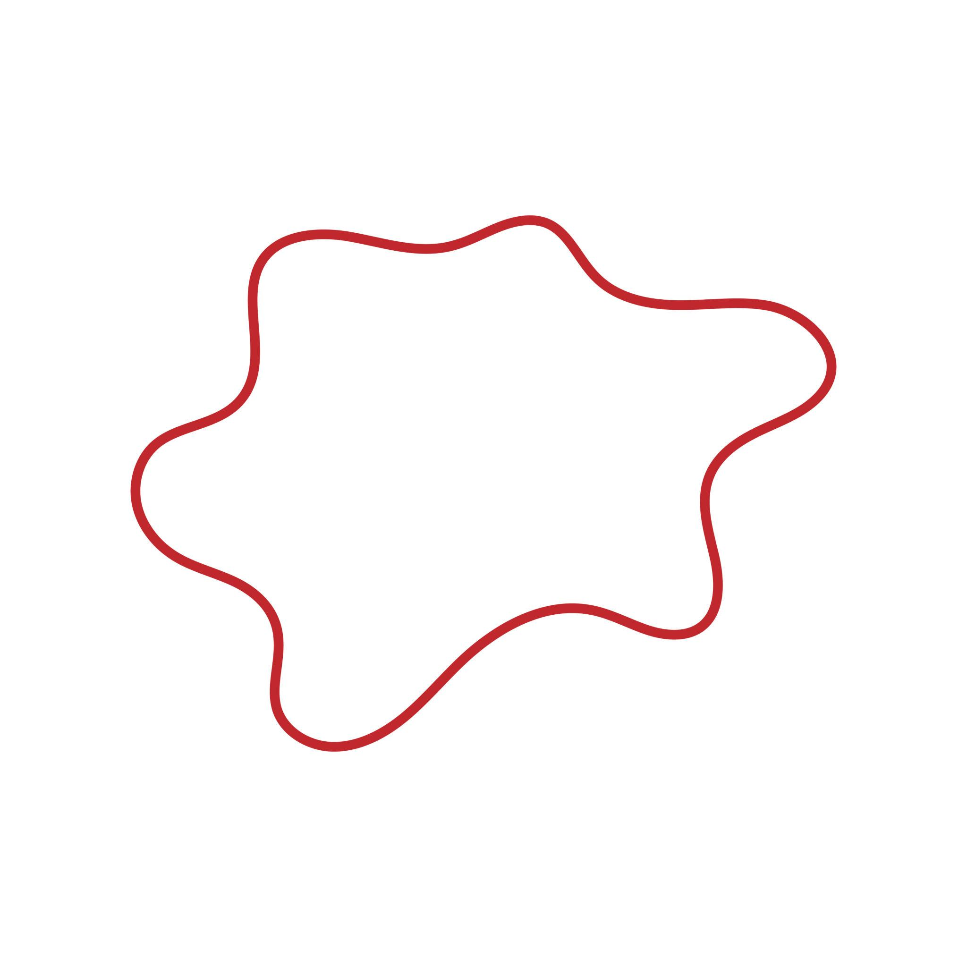
A closed curve with continuously changing curvature.

3. Irregular Asymmetric Closed Curve
# Source: AI Source: Provided by: [Data Path: Persons Table -> ID Column: 1, Name_En Column: Motasem Essam] -> From: [ChatGPT] on [7/25/2026]
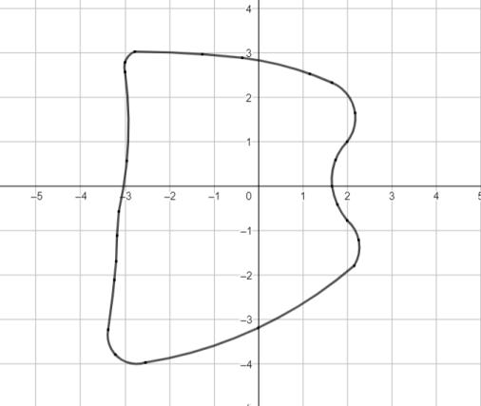
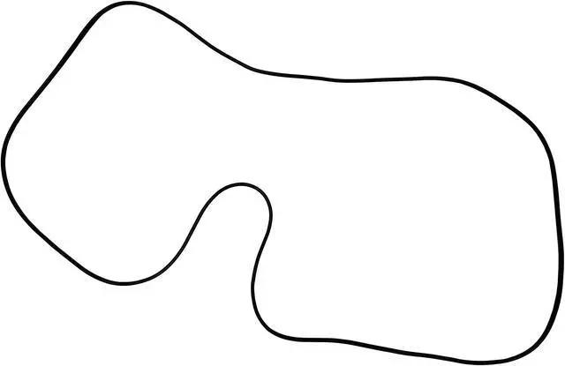
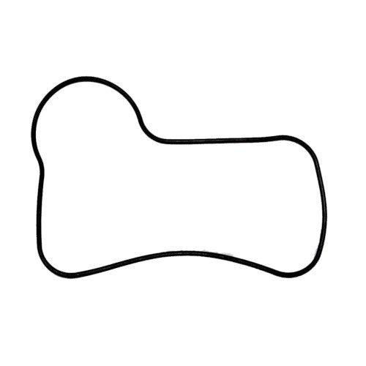
A closed curve without regular reflectional or rotational symmetry.

4. Natural Irregular Closed Curve
# Source: AI Source: Provided by: [Data Path: Persons Table -> ID Column: 1, Name_En Column: Motasem Essam] -> From: [ChatGPT] on [7/25/2026]
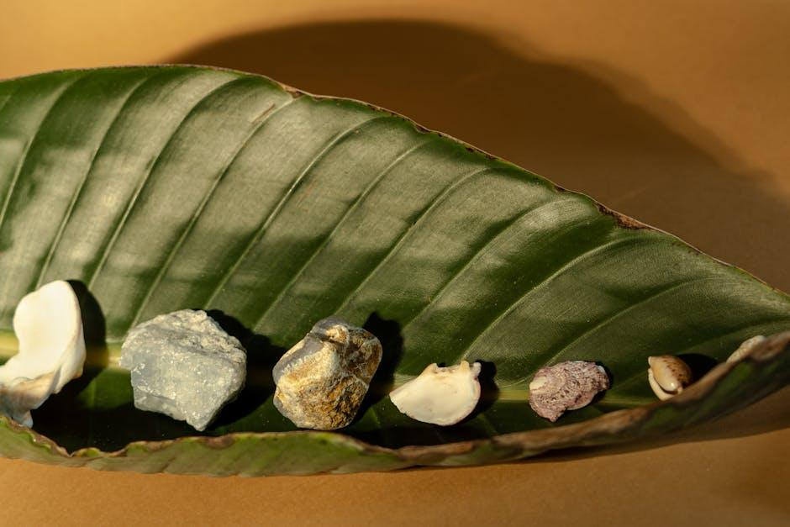
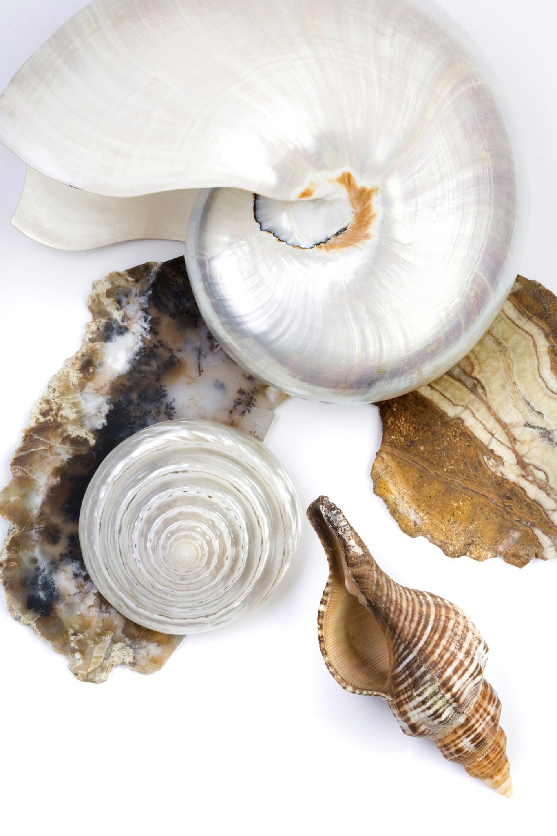
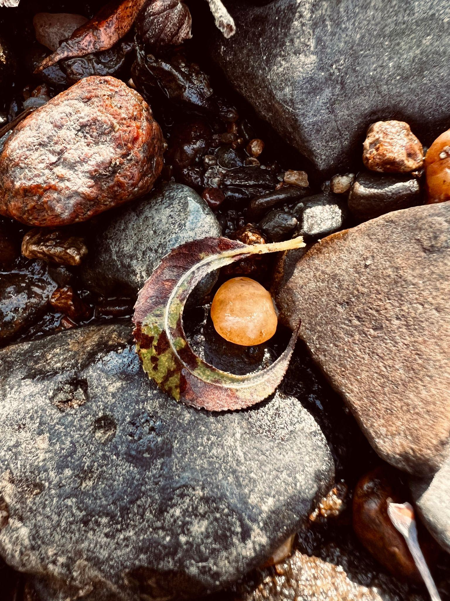
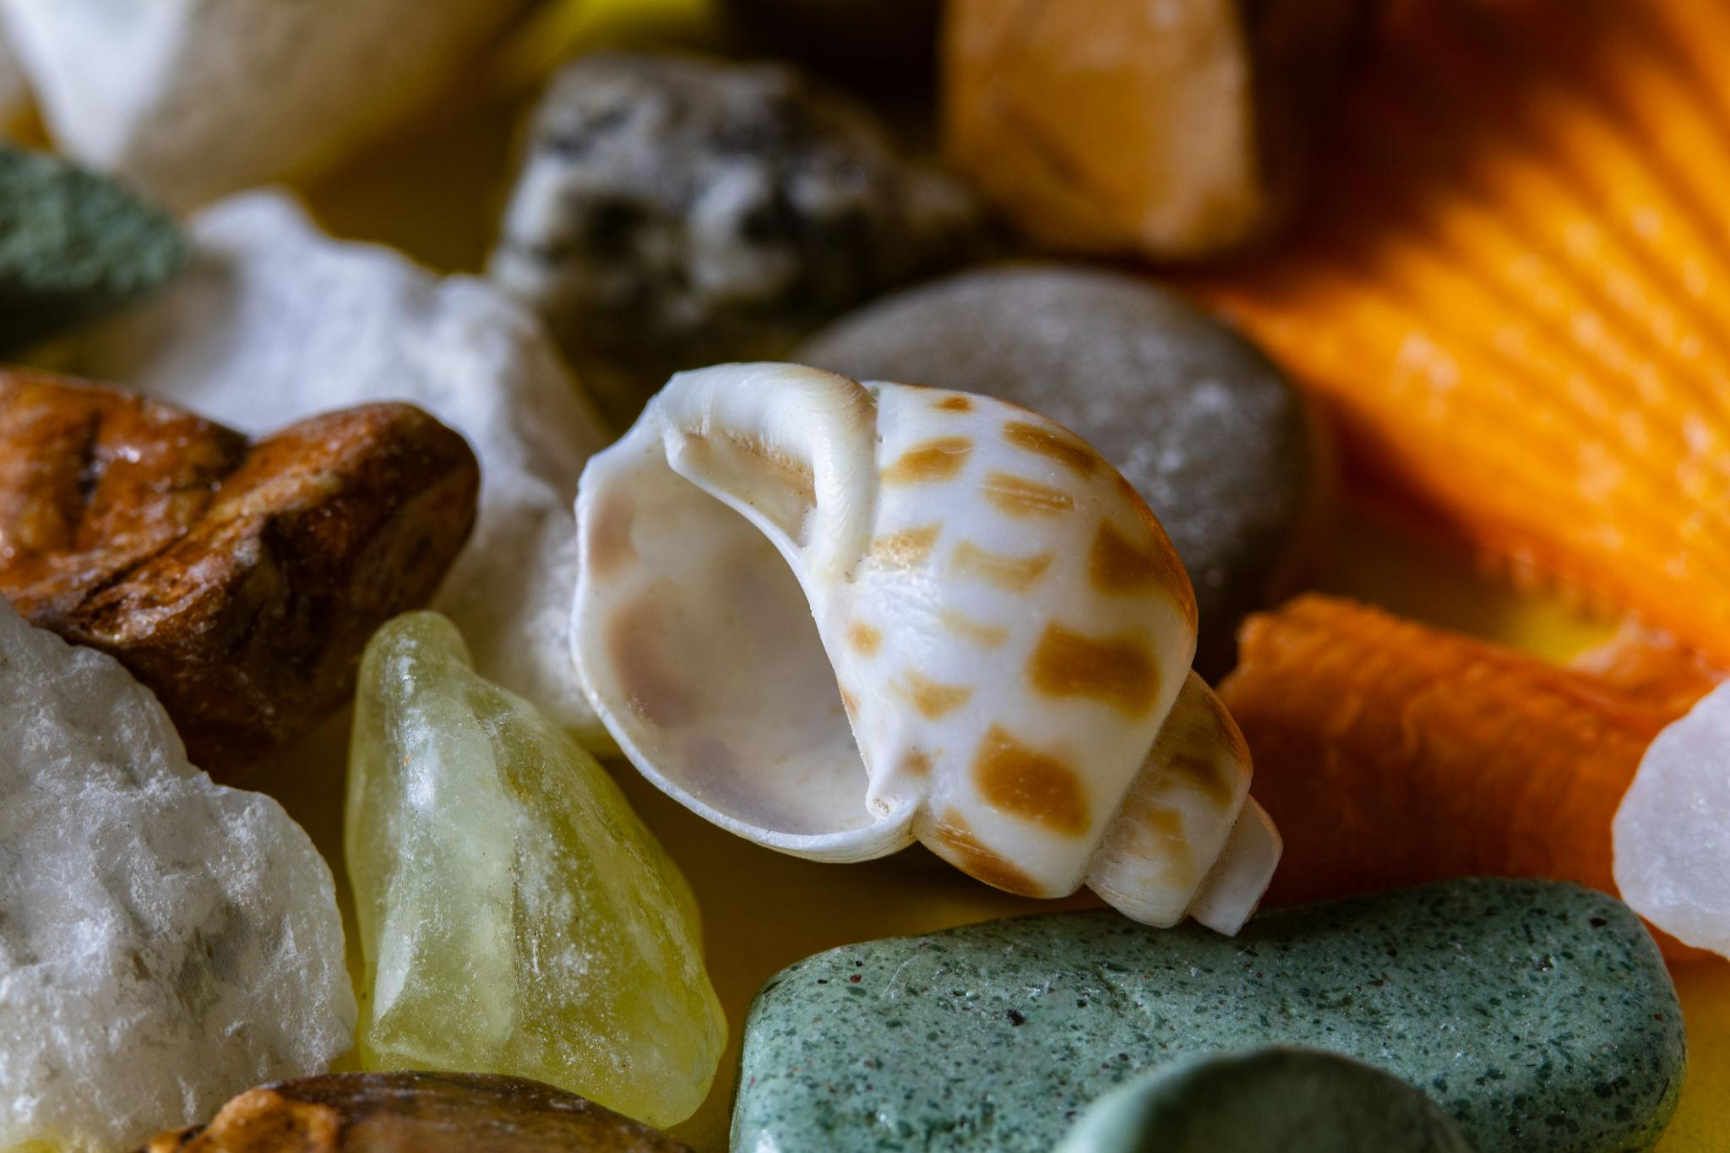
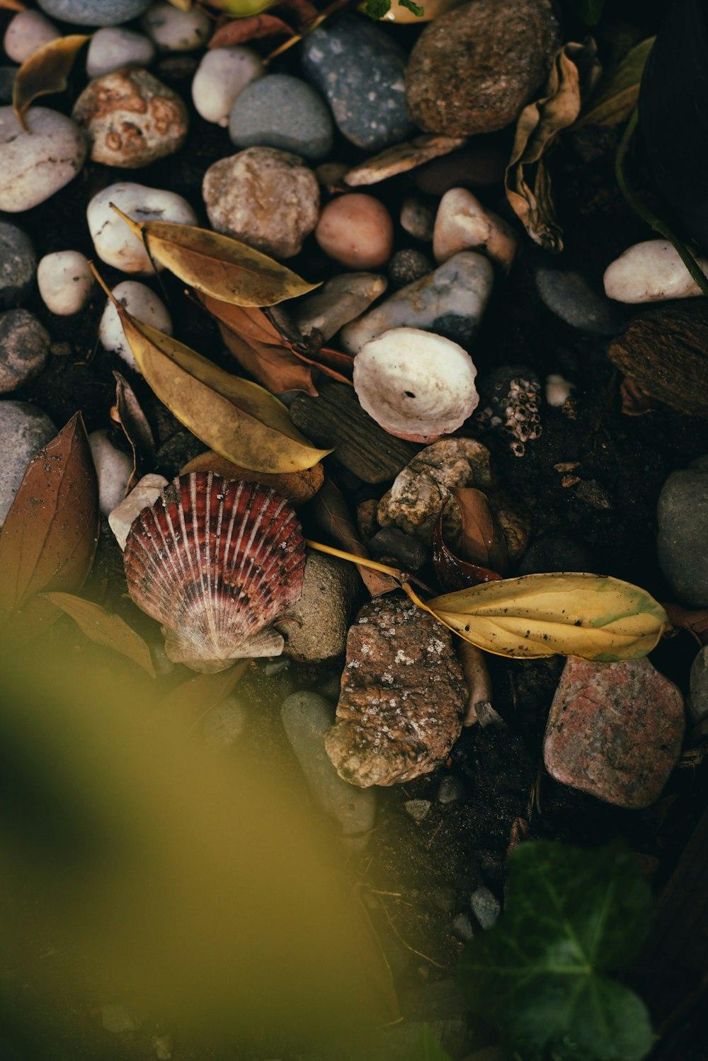
Natural objects can have irregular closed boundaries, such as certain leaves, stones, shells, and other natural forms.

Closed vs. Open Curves

Closed Curve
# Source: AI Source: Provided by: [Data Path: Persons Table -> ID Column: 1, Name_En Column: Motasem Essam] -> From: [ChatGPT] on [7/25/2026]
The endpoint returns to the starting point:
$$P_{\text{start}}=P_{\text{end}}$$
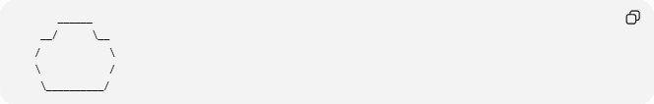
______
__/ \__
/ \
\ /
\__________/

Open Curve
# Source: AI Source: Provided by: [Data Path: Persons Table -> ID Column: 1, Name_En Column: Motasem Essam] -> From: [ChatGPT] on [7/25/2026]
The endpoints remain separate:
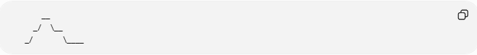
__
_/ \__
_/ \____
Therefore:
$$\boxed{\text{Closed Curve}≠\text{Open Curve}}$$

Regular vs. Irregular Closed Curves
# Source: AI Source: Provided by: [Data Path: Persons Table -> ID Column: 1, Name_En Column: Motasem Essam] -> From: [ChatGPT] on [7/25/2026]
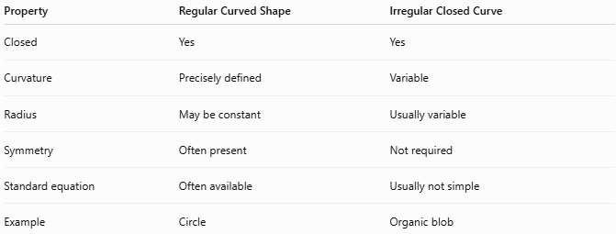
Property | Regular Curved Shape | Irregular Closed Curve
Closed | Yes | Yes
Curvature | Precisely defined | Variable
Radius | May be constant | Usually variable
Symmetry | Often present | Not required
Standard equation | Often available | Usually not simple
Example | Circle | Organic blob
A circle is a particularly important closed curve:
$${\left(x-h\right)}^{2}+{\left(y-k\right)}^{2}=r^{2}$$
An irregular closed curve generally does not have such a simple representation.

Mathematical Representation
# Source: AI Source: Provided by: [Data Path: Persons Table -> ID Column: 1, Name_En Column: Motasem Essam] -> From: [ChatGPT] on [7/25/2026]
An irregular closed curve can be represented parametrically:
$$x=x\left(t\right), y=y\left(t\right)$$
where the parameter satisfies:
$$x\left(a\right)=x\left(b\right), y\left(a\right)=y\left(b\right)$$
This condition indicates that the curve returns to its starting point.

Area Enclosed by an Irregular Closed Curve
# Source: AI Source: Provided by: [Data Path: Persons Table -> ID Column: 1, Name_En Column: Motasem Essam] -> From: [ChatGPT] on [7/25/2026]
A closed curve creates a bounded region, so it can have an enclosed area.
For a parametric closed curve, the area can be calculated using:
$$\boxed{A=\frac{1}{2}\oint{\left(x,dy-y,dx\right)}}$$
For a digitally represented irregular shape, the area can also be estimated using:
- Grid counting.
- Pixel counting.
- Coordinate geometry.
- Numerical integration.
- Computational geometry.

Perimeter / Curve Length
# Source: AI Source: Provided by: [Data Path: Persons Table -> ID Column: 1, Name_En Column: Motasem Essam] -> From: [ChatGPT] on [7/25/2026]
The boundary length of an irregular closed curve is its arc length.
For:
$$x=x\left(t\right), y=y\left(t\right)$$
the length is:
$$\boxed{L=\int_{a}^{b}{\sqrt{{\left(\frac{dx}{dt}\right)}^{2}+{\left(\frac{dy}{dt}\right)}^{2}}},dt}$$

Types of Irregular Closed Curves
# Source: AI Source: Provided by: [Data Path: Persons Table -> ID Column: 1, Name_En Column: Motasem Essam] -> From: [ChatGPT] on [7/25/2026]
Within your classification system, you can distinguish:

1. Organic Irregular Closed Curves
# Source: AI Source: Provided by: [Data Path: Persons Table -> ID Column: 1, Name_En Column: Motasem Essam] -> From: [ChatGPT] on [7/25/2026]
Smooth, natural-looking closed curves.
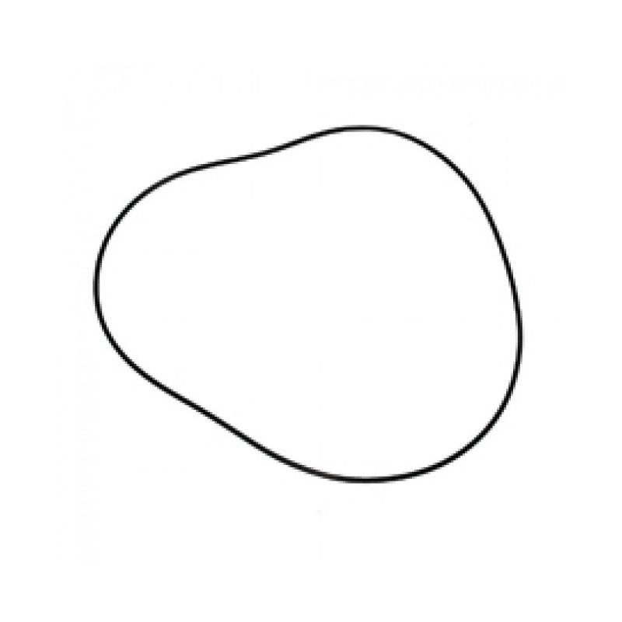
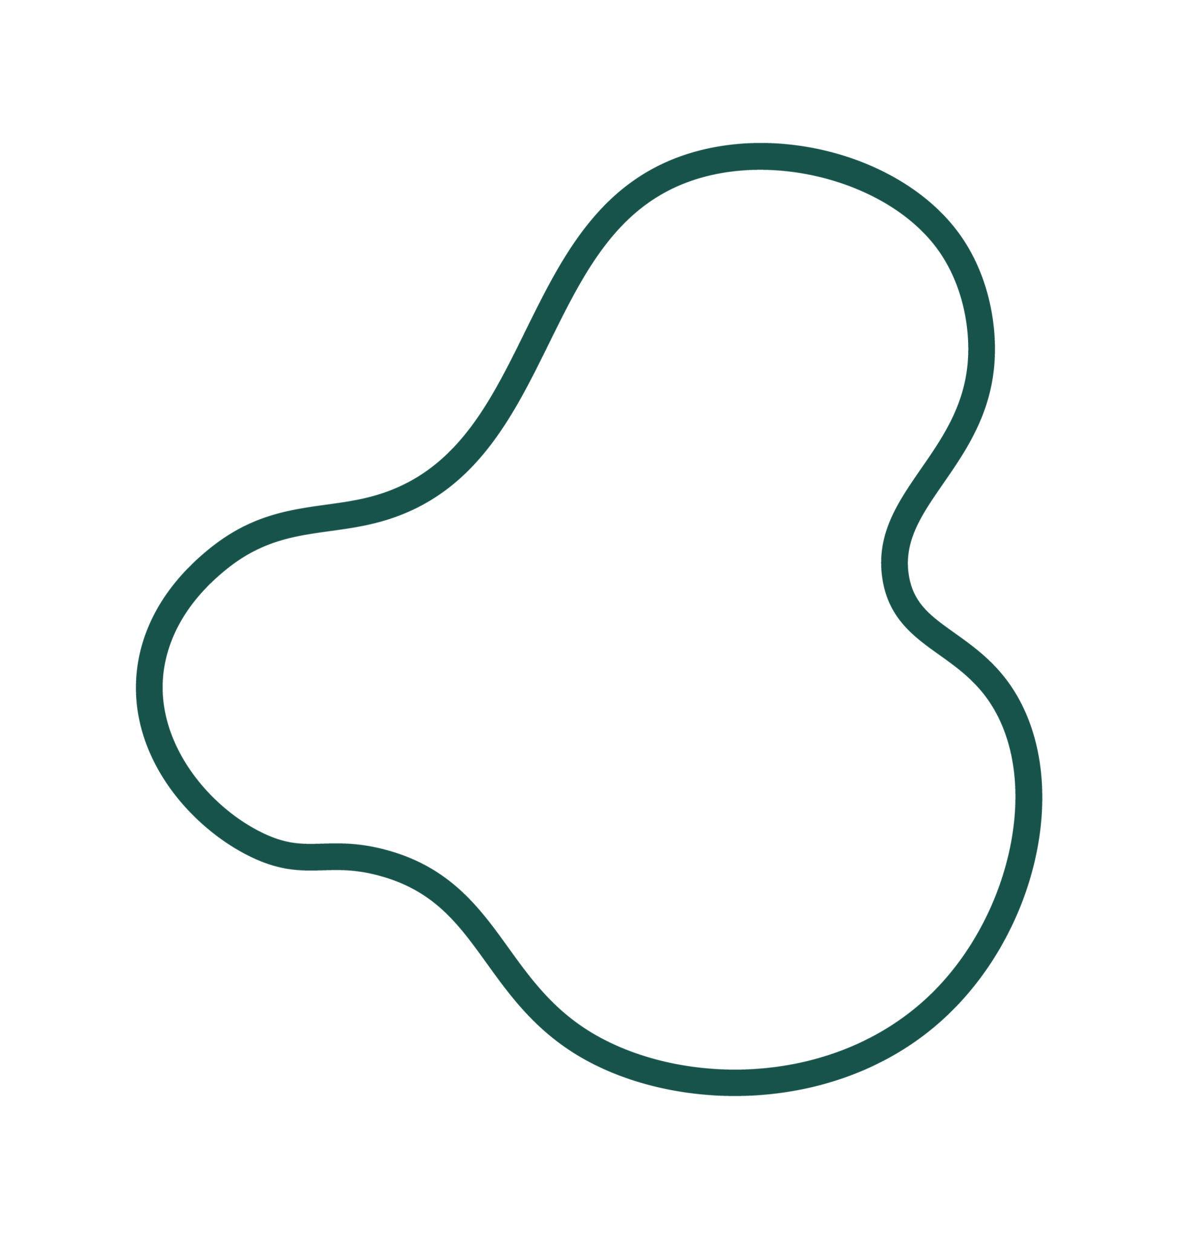
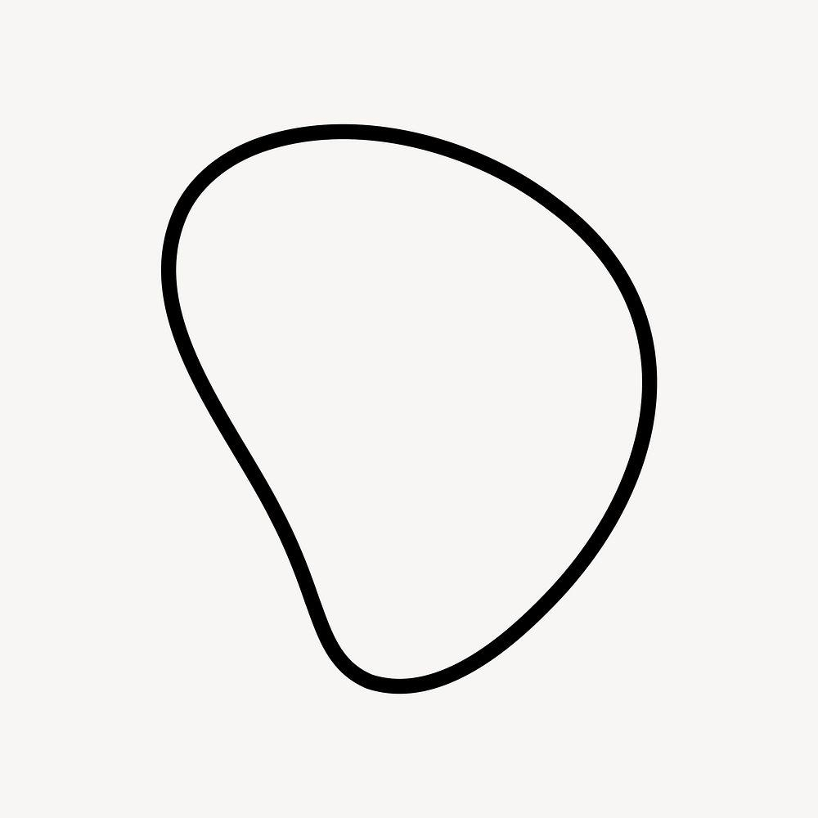
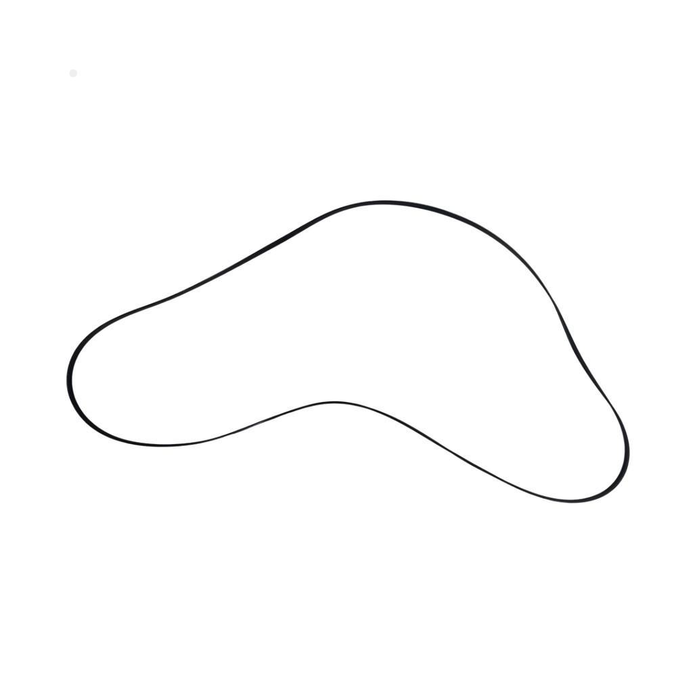

2. Freeform Irregular Closed Curves
# Source: AI Source: Provided by: [Data Path: Persons Table -> ID Column: 1, Name_En Column: Motasem Essam] -> From: [ChatGPT] on [7/25/2026]
Artificially designed closed curves with freely controlled curvature.
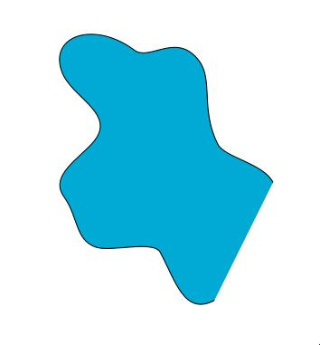
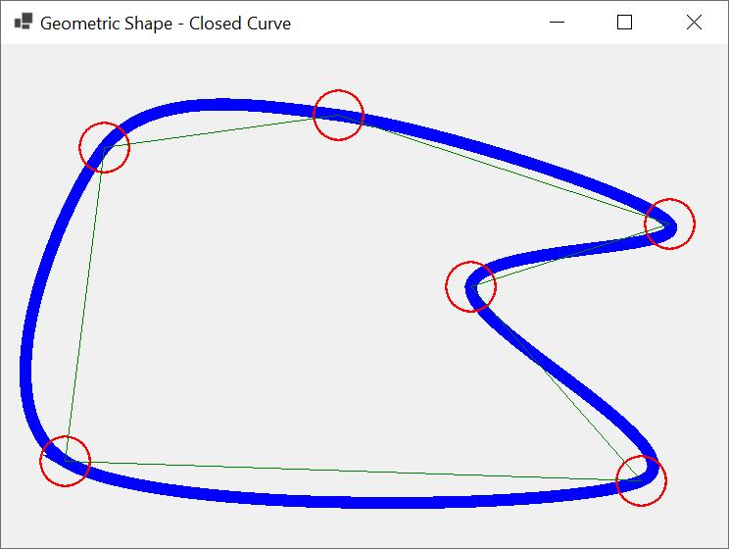
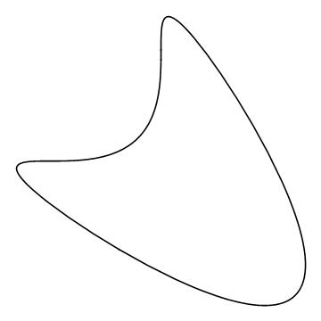
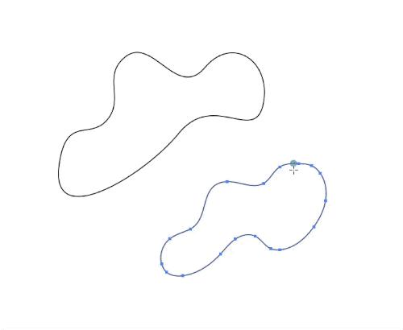
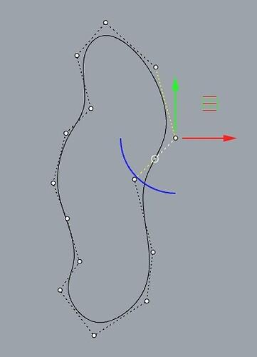

3. Natural Irregular Closed Curves
# Source: AI Source: Provided by: [Data Path: Persons Table -> ID Column: 1, Name_En Column: Motasem Essam] -> From: [ChatGPT] on [7/25/2026]
Closed boundaries occurring naturally in objects or forms.
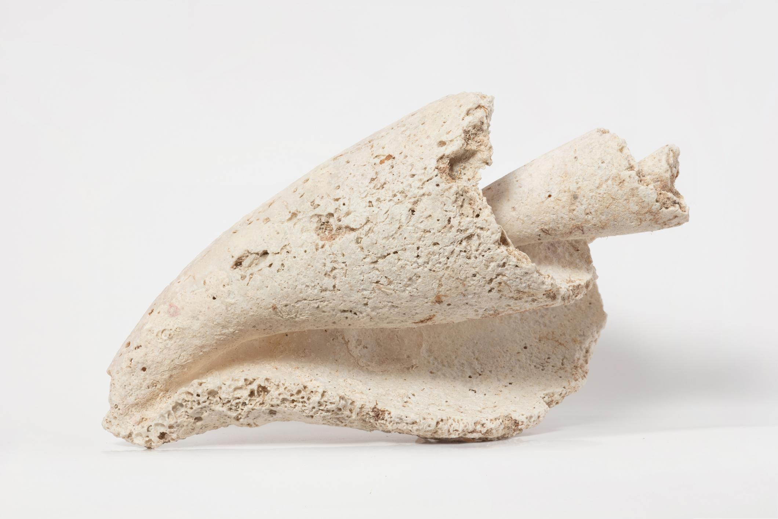
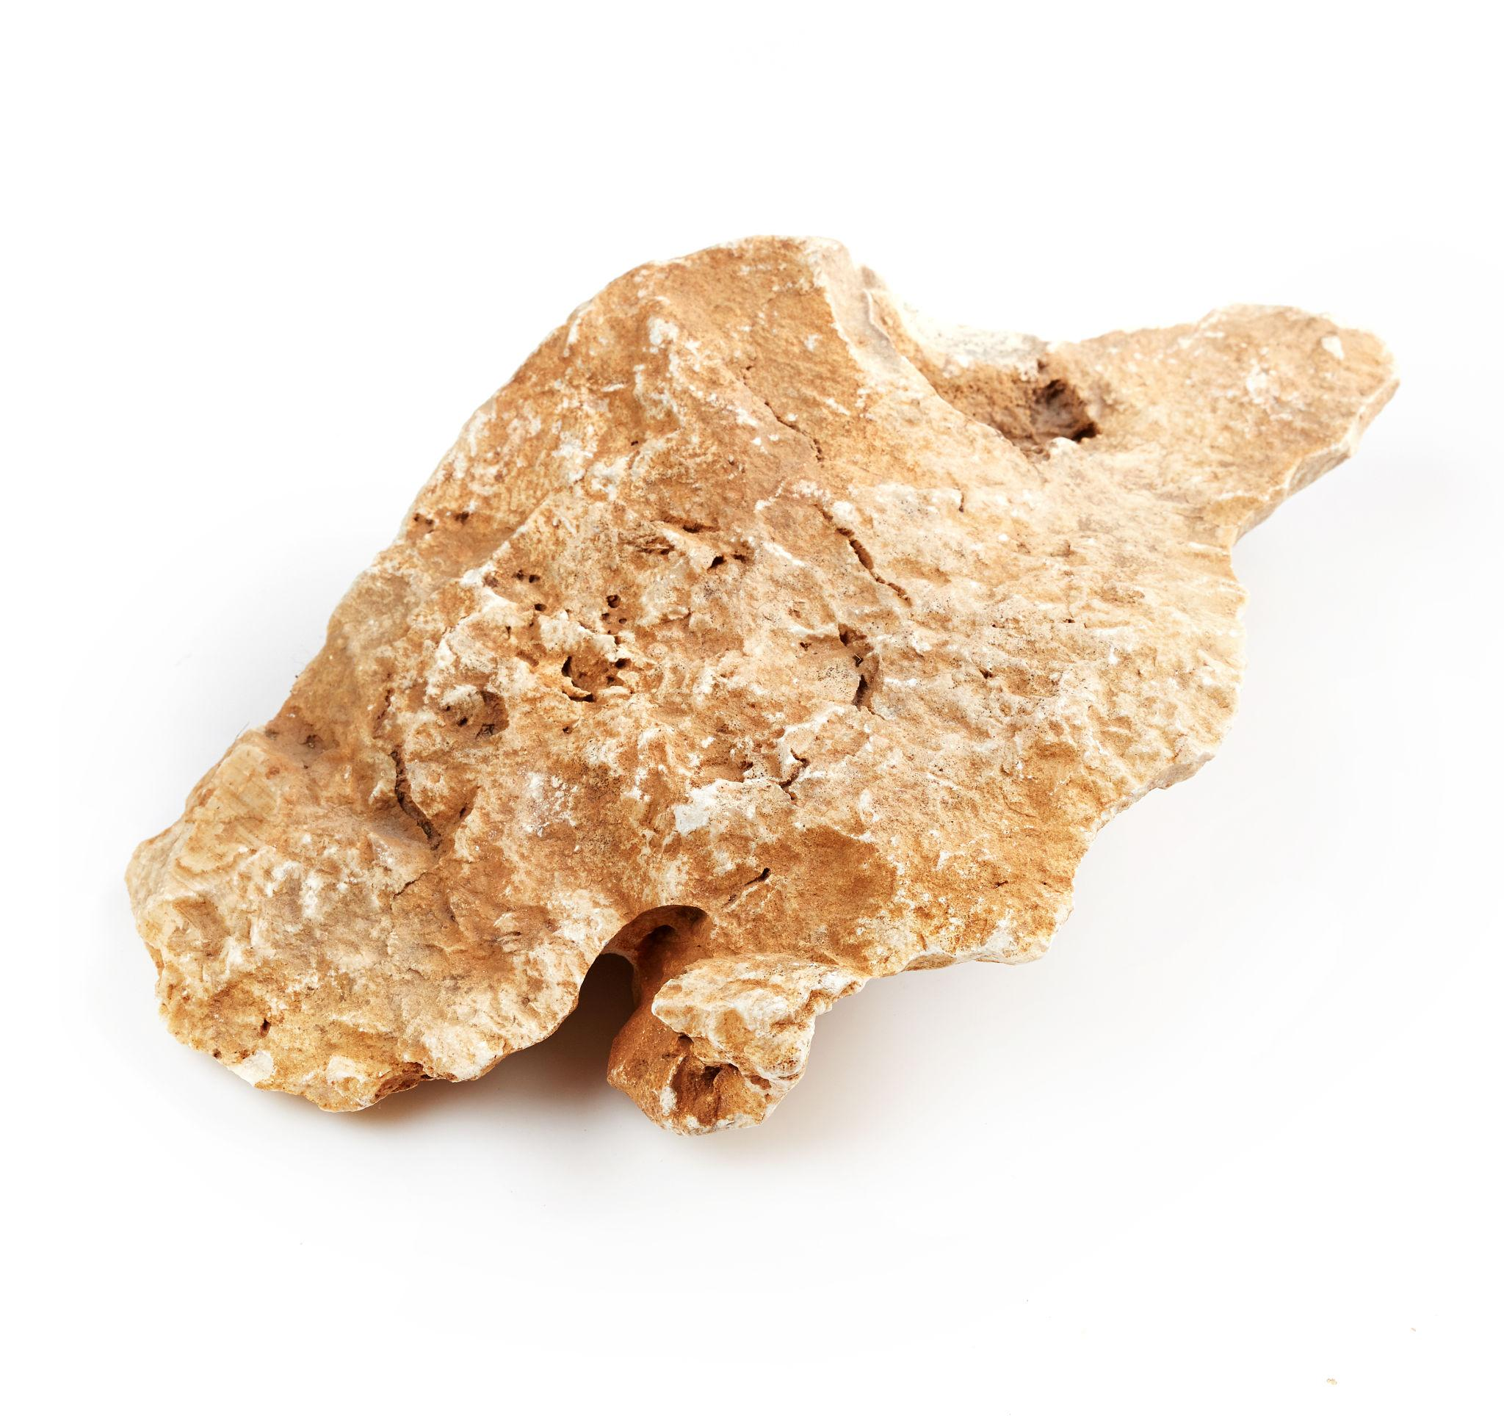

4. Asymmetric Irregular Closed Curves
# Source: AI Source: Provided by: [Data Path: Persons Table -> ID Column: 1, Name_En Column: Motasem Essam] -> From: [ChatGPT] on [7/25/2026]
Closed curves lacking regular symmetry.
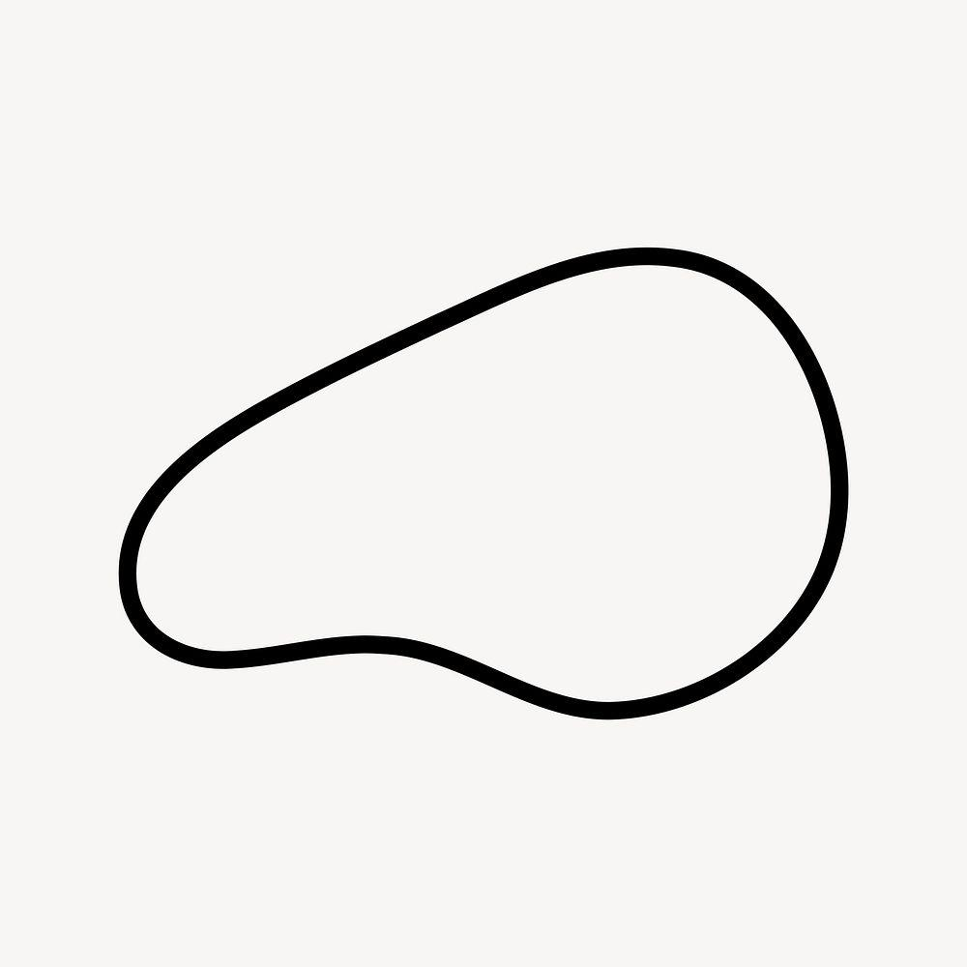
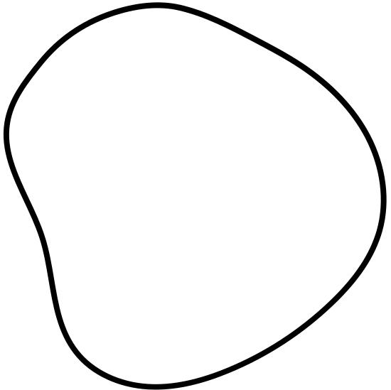

5. Wavy Irregular Closed Curves
# Source: AI Source: Provided by: [Data Path: Persons Table -> ID Column: 1, Name_En Column: Motasem Essam] -> From: [ChatGPT] on [7/25/2026]
Closed curves with repeated or variable undulations.
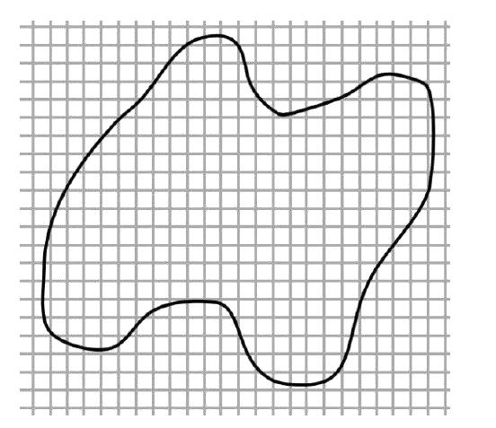
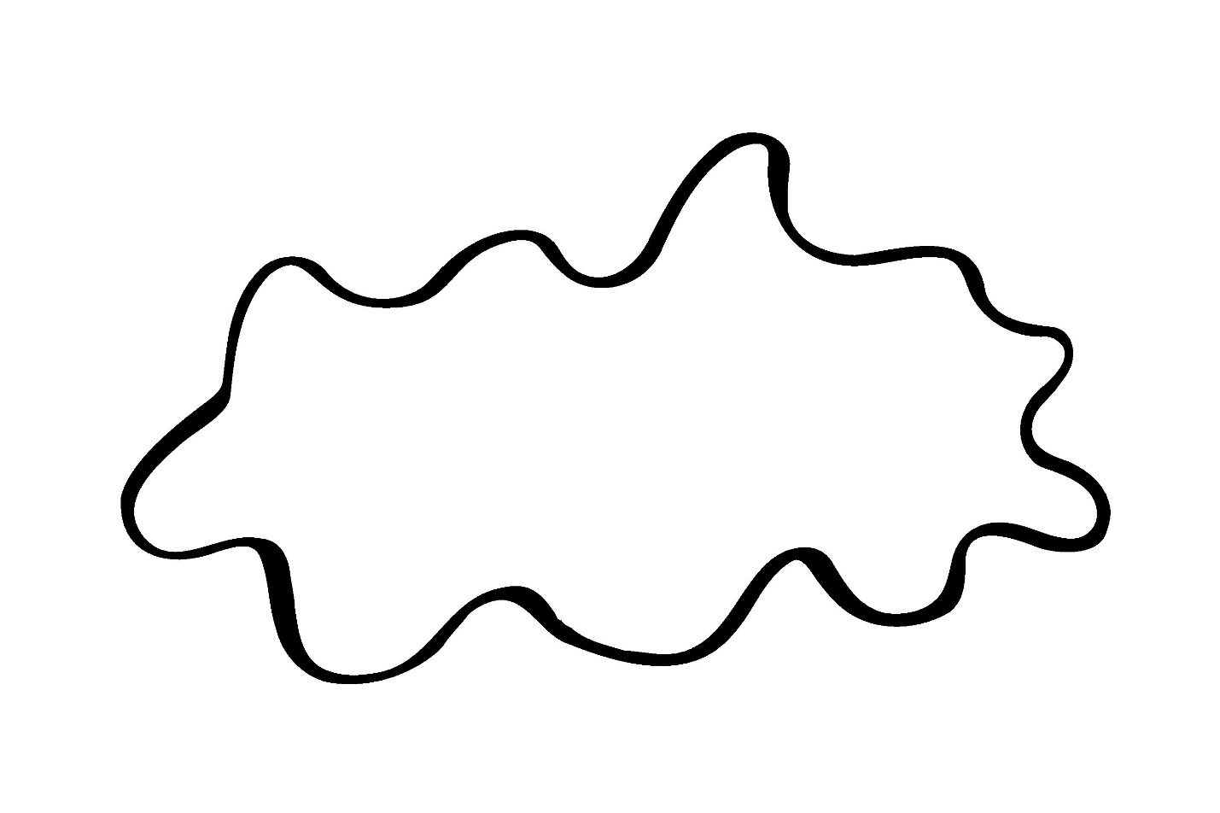
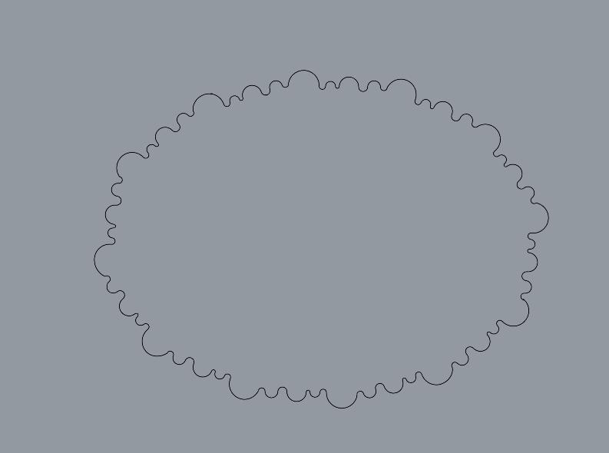

Important Distinction
# Source: AI Source: Provided by: [Data Path: Persons Table -> ID Column: 1, Name_En Column: Motasem Essam] -> From: [ChatGPT] on [7/25/2026]
An Irregular Closed Curve is not necessarily the same as an Irregular Curved Shape.
A curved shape may be:
- Open → does not enclose a region.
- Closed → encloses a region.
Thus:
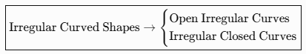
Irregular Curved Shapes → {
Open Irregular Curves
Open Irregular Curves

Applications
# Source: AI Source: Provided by: [Data Path: Persons Table -> ID Column: 1, Name_En Column: Motasem Essam] -> From: [ChatGPT] on [7/25/2026]
Irregular closed curves are important in:
- Plane Geometry
- Computational Geometry
- CAD
- Computer Graphics
- Image Processing
- GIS
- Architecture
- Industrial Design
- Biology
- Geography
They are especially useful when representing real-world boundaries that cannot be accurately modeled by simple geometric shapes.

Key Points
# Source: AI Source: Provided by: [Data Path: Persons Table -> ID Column: 1, Name_En Column: Motasem Essam] -> From: [ChatGPT] on [7/25/2026]
An Irregular Closed Curve:
$$\boxed{\text{Closed}} \\ \boxed{\text{Curved}} \\ \boxed{\text{Irregular}}$$
and therefore:
- Starts and ends at the same point.
- Encloses a bounded region.
- Has variable curvature.
- Does not require a constant radius.
- Does not require symmetry.
- Usually does not have a simple standard geometric equation.

Conclusion
# Source: AI Source: Provided by: [Data Path: Persons Table -> ID Column: 1, Name_En Column: Motasem Essam] -> From: [ChatGPT] on [7/25/2026]
Irregular Closed Curves are continuous, non-standard curved boundaries that return to their starting point and enclose a bounded region. Unlike regular curves such as circles and ellipses, their curvature can vary freely and they do not require a fixed radius or regular symmetry. They can be natural, organic, freeform, asymmetric, or wavy, making them useful for representing complex boundaries in geometry, CAD, computer graphics, GIS, architecture, biology, and geographical modeling.

